Location London 7- 8 March: programme

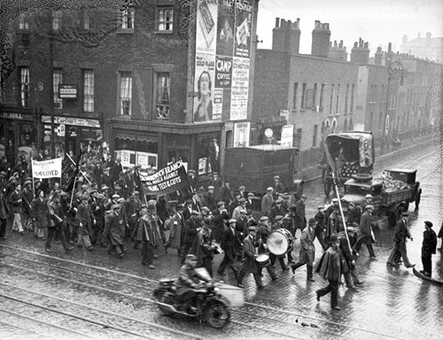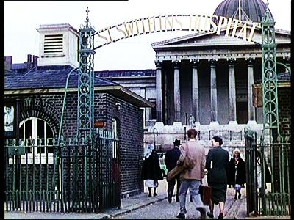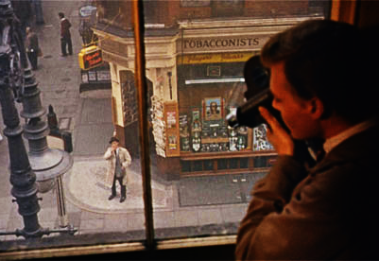

Day 1/ Friday March 7, Senate House (Senate Room, 1st floor)

1.30-2.00: welcome and introduction

2.00-3.45: chair: Charlotte Brunsdon (University of Warwick)

- Robert Murphy (De Montfort University) ‘An American in London: Jules Dassin and Night and the City’
- Philip Horne (University College London) ‘Placing Peeping Tom’
- Maureen Thomas (University of Cambridge) ‘Do I See You? London Mirror’ (on London in Bollywood cinema)
- Karolina Kendall-Bush (University College London): ‘Location Limehouse: Visiting the Streets of London’s Lost Chinatown’

4.15-5.30: chair: Roland-François Lack (UCL)

- Richard Koeck (University of Liverpool), on the Cinematic Geographies of Battersea
- Aileen Reid (Survey of London, Bartlett School of Architecture), ‘Battersea in Film: a Case of Location Anxiety?’
- Chris O’Rourke (University College London) ‘In the Streets of Film-land: Locating London’s Cinema History’

5.30-6.10: chair Ian Christie (Birkbeck)

- Thomas Christensen (Danish Film Archive): ‘Mapping Early Films: Copenhagen as a Case’

6.20: drinks reception in the Gustave Tuck Lecture Theatre, University College London

*********

Day 2/ Saturday 7 March, Birkbeck Cinema and Senate House

9.45 (for 10.00): Birkbeck Cinema, 43 Gordon Square

- Preview screening of Another London, a film written and presented by architecture historian Robert Harbison, introduced by the director Ektoras Arkomanis

11.40-1.00: Chair: Roland-François Lack

- Angelina Karpovich (Brunel University): ‘Jacob Richter’s London’ (on Lenin in London)
- Eleni Liarou (Birkbeck): ‘London’s Modern Babylon: Film, Memory and Public History’
- Martin Brady (King’s College London) on The Vanishing Street

1.00: lunch at Senate House

2.00-3.30:
- Ian Christie (Birkbeck): ‘Drab Streets: London Crime Scenes’
- Les Roberts (University of Liverpool): ‘Locating the City in Film: Navigating the Archive City’
- Closing discussion.

University of London Screen Studies Group / All concessions £20, or £10 per day

